S.E.L.F.

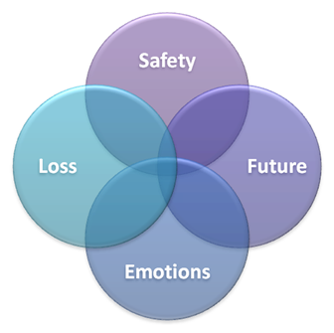

**What happened?**

**Safety:**

* *Physical*
* *Psychological*
* *Social*
* *Moral*

**Emotions:**

**Loss:**

**Future:**